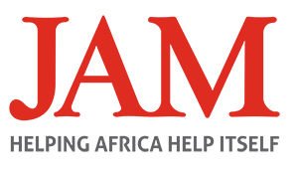
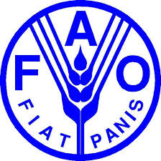

FINAL REPORT

Report | (23/12/2015]

REPORTING ON LETTERS OF AGREEMENT (LOAs)
NAME OF “SERVICE PROVIDER” | Joint Aid Management (JAM)
LOA No. | SS/076/15 (In Kind)
PROJECT TITLE | Distribution of FAO Emergency Livelihood Kits to Support 6,000 HHs in Jonglei State Nyirol County.
PROJECT LOCATION (State - County level) | Jonglei State
PROJECT AMOUNT | 6,000 HH
PROJECT DURATION | 3 Months
REPORTING PERIOD | 2015
DATE OF SUBMISSION | 17/12/15
TYPE OF REPORT | Mid-term Report
TYPE OF REPORT | Final Report Y
TYPE OF REPORT | Other (mention the type of report)
CONTACT PERSON | Edward James Thomas
EMAIL AND PHONE NUMBER | Edward.thomas@jamint.com +211 914 857 802

- Executive Report
The situation in Jonglei remain unstable from the time of first round of sensitization for registration that took place on JAM’s entry in Oct- 2015. Since then as reported, the FAO Emergency Livelihood Response Programme (ELRP) was delayed for some months due to difficulties arising from continued conflict and displacement throughout the project timeframe including the main part of this reporting period. This led to limited access to the payams of operation in Nyirol County, yet, a robust response was/is heavily required.The IDPs in the area moved in from Malakal, Bor, Ayod, Korfolus, Nasir and Ulang, and after constant coordination with FAO and attempted missions to the field, we finally got an opportunity to serve Nyirol County through FAOs Emergency Livelihood Rapid Response (ELRR) Operation ‘HAROLD’. The rapid response team once again carried out meetings with local authority and Chiefs before registration to make sure that they were fully engaged in the implementation process, all the way from start of registration in Oct. And the beneficiary update was sent back to back to FAO to plan the operation. But throughout the whole of the planning process due considerations of the beneficiaries in ‘hiding’ were made in view of the need to adhere to the humanitarian imperative of ‘Do No Harm’. JAM SS registered beneficiaries from among both IDPs and host communities in swamp dominated Thol and Pading payams. 6,000 HH were served with livelihood kits from the ELRP during this rapid response, but due to conflict and insecurity that was still ranging in the area follow-up was difficult. The distribution took place at the start of the dry season.
- Background
Nyirol County is one of the 3 counties that constitute the Greater Akobo. It is situated to the north while Akobo County to the east and Uror County to the south. These three counties are also known as Greater Lou. The people who inhabit the area are one community speaking one language and they practice mixed farming.
Currently Nyirol County is divided into three Counties namely Nyirol East ( Lankien), Nyirol West( Dukir or Pading) and Nyirol North (Pultruk). The area is currently under the control of SPLM IO.

Breakdown of payams in the three Nyirol Counties

 | Counties
 | Nyirol East | Nyirol West | Nyirol North
Payams | Thol, Tut, Chuil, Waat,  Dualjany, Pagor | Keth, Tip, Wenyal, Wechliethni | Pultruk, Riang, Dengdor 1, Dengdor 2  Limkuon

- General Situation
Nyirol County is facing a further food crisis, due to continuing displacement by conflict, high rates of death, injury and disease during this reporting period by rainy season and EMF gap. Consequently, effecting livelihoods due to the widespread malnutrition, with 90 per cent of counties in GUN above the emergency threshold. The production has seriously been effected this season, destroying the viability of communities and generating new and recurrent displacements of vulnerable populations from intensified violent conflict, which has caused economic stress in generating inflation and shortages of critical goods and services. However, the scale of the suffering in Nyirol County, one of Organization operate in the areas but supported by WFP doing food distribution; people fled their burning homesteads, killing of innocent civilian. In most payams the situation level usually seen only during famine, they have lost loved ones, their few belongings, and their livelihoods, extreme violence has left farmers unable to sow or harvest their crops, fishermen barred from rivers site (Chuil), and Cattle herders left destitute as their cattle have been raided daily by Murle. The Murle area is located into Southern Jonglei while they are also part of Jonglei Tribes. In the current situation, Many have only survived by using up their resources – selling their assets, or relying on wild fruits and plants, and, as a last resort, killing their livestock if any.

Overall Wellbeing & Livelihoods – Agriculture & Fishing/Aquaculture:
- Now Predominantly Agro-pastoralists & Fishing Communities – in normal situation livelihood could nearly be classifies as follows: Agricultural (Farmers) 50%, Fishing 30%. Livelihood sources have been disturbed through systematically looting of livestock, therefore, people have no access to everything because the population is too high. These communities rear animals such as cattle, goats, sheep and poultry but due to this conflict that let to many cattle losses livelihoods have changed to be more Fishing and agricultural but in this time, it’s very difficult because Nyirol is dries area no river.
- Subsistent Farming - According to key informants, 50% of the population were engaged in agricultural activities compared to 90% before the conflict in the normal year seasonal calendar.
- Cultivation – Most households have been unsuccessful to their expectations and farming ranged from 0.1–0.5 Feddans per household, reason being disruption due to insecurity as majority people have been displaced. Compared to normal 2.5-5 Feddans a household can cultivate in a year, mainly women, elderly and children using traditional tools making coverage minimal and the produce less.
- Limited Rainfall – long dry spell unabled to support crop production in the area, especially the Sorghum which was at the flowering stage. Those in low lying areas can have a harvested because the Vegetable arrive let as well as the active vegetable gardening were prapered in all 12 Villages but some of them will not work because this is dries season, which mean it’s be very difficult for them to seccue.
- Increased Fishing Livelihoods – Farms emptied due to conflict and failed subsistence farming production due to not sufficient timely access to quality field seed saw a shift to fishing (80% share) for the population engaged (Source: EFSA 2015, JAM Participation). However, challenging with limited or inadequate fishing gears or apparatuses in addition to; coping strategies before normal harvesting period pre JAM/FAO intervention.
- Main Survival Mechanism Currently – Water lilies, Jews melon and fish: Water lilies availability is most likely to reduce significantly in the next two months, particularly in Nyirol area, most of the Community went to Chuil because the population is expected to be in severe famine. They went because Chuil have enough fish.
- Meals Eaten - People consume one meal a day.
- Bad Condition of Population - General sickness and disease throughout the county, for example, you can walks for 12 hours through footing, where mostly people are staying in and around the Lou. Disease riddles them and can’t get treatment, just too far to travel back to the home, because they still fear for their lives. People appear very much emaciated, weak, with fever, joint pains, issues for being in constant in far distain, malaria, bilharzia, etc. Significant cases of edema amongst children under 5, consequently, not always insecurity that kills the population but disease. Especially malaria is too dangerous in this winter Season. MSF report 4,562 Patients were admitted during NGO weekly meeting in Lankien. MSF and CMA are only providing 2 Organization providing some Medicine to community but the area is bass they didn’t able to cover all the population.
- Purpose / Objectives (include photographic evidence)
Output – Emergency Livelihood Support provided to affected households in the form of FAO Emergency Kits safely and timely delivered to food insecure and displaced communities – Output Indicators:
- 6,000/6,000 households supported with vegetable seed
- 6,000/2,100 households supported with fishing kits
6,000/6,000 assorted vegetable seeds - No tools distributed
- 5,000/2,100 of Fishing Kits distributed
- #? of Post distribution report(s) delivered
  - Activities 1 – Mobilization and Sensitization of Communities at County/Payam Level
Community consultations were carried out, through the County Commissioner for the first sensitisation from introduction of the programme in the first reporting period, and his Administration Leaders for the first registration; also, again for registration and eventually arrival as the programme (always going through the chain of authorities) changed from full ELRP to a Rapid Response Operation, therefore, it was explained why field crop seeds were not brought, and why they were not for this distribution. Outcome, happy to accept but said, the seasonal calendar is different and if we had brought for that period of time, especially sorghum, that would have been very needed (it was explained why field crop seed is not apart of the heli operation). The Chiefs of each Village (12) of JAMs operation explained with JAM field staff, which sensitized the community who were very grateful, especially for the fishing gear (twine/nets and hooks).
Consultation meeting with local chiefs in Guit town the capital of the County 23-April-2015

  - Activities 2 - Identification of Beneficiaries and Registration
Field Programme Supervisor coordinated with FSL Sp. Manager at Juba level/Nyirol and field level with their team – Field Officer Carry out the identification and verification from registration, by working with the Community Chiefs and Community Volunteers to identify vulnerable groups and highlighted them for the distribution plan. However, this was Vegetable and Fishing gear coverage through the area in Nyirol County.

  - Activities 4 – Collection and Stock FAO Emergency Kits from Juba
FAO delivered 3 rotations from Rumbek/Juba Pipeline to Nyirol County 6,000 Vegetable Seeds and 2,100 Fishing gears of spools of twine/fishing net and hooks for 2 payams only.

FAO ELRR Helicopter- Biil09/
  - Activities 5 - Distribution of Inputs
Registration had taken place Oct so that distribution would be in the right areas reference to the HH targets within the payams, or the nearest Final Distribution Points (FDP) for JAMs registered beneficiaries and the ‘Do No Harm’ Policy was factored into the programme management as FAO and JAM worked together to achieve the ELRR Helicopter Operation. 2,100 fishing kits and 6,000 kits of veg. kits distributed to 6,000HHs.

Distribution taking place in Lankien and Pading -18-Nov-2015

  - Activities 6 – Post Distribution Monitoring
Due to the ‘No Harm Policy’ including the pull factor, with the nature of ELRR Operation, not many of the beneficiaries couldn’t hang around, a lot of the time they came to one of the three FDPs and collected their agricultural inputs and had a drink of water, quick chat and left, however, the field team did manage to collect the data from primary sources (beneficiaries HHs) that were around longer and sample of group discussions, plus the FAO data format with PDM data collection was done in a participatory approach with beneficiaries and local Chiefs/Leaders.

- Problems Faced
- Insecurity in the area is one of the major constraints to people who used to move from one location to another.
- Walking long distance for 12hrs is challenging.
- People falling sick due to change of their surroundings.
- Food insecurity become when you go to other area.
- Water for drinking becomes scarce whenever staff go to the field and for the community at large.
- Internet access is a problem in the area.
- Transportation is become difficult when you are moving with your heavy luggage.
- Lack of Farm input like hoe, water cane, bucket and Fence.
- Control of insect becomes difficult due to lack of insecticide.
- Lack of machine like generator for pumping water in the Farm.
- Transportation – people are just using man power carrying heavy luggage to from far distances between locations.
- Window of Opportunity - Violence outside of the Location is preventing people from safe access by road/bush to the area. Ergo, conflict and insecurity situation dictates restriction of movement and the insecurity caused our beneficiaries to move out of JAMs areas of operation towards and into the distribution point
- Programme Supervisor and Field Officer walk up 3-5 days to reach the target locations.
- Access to staff accommodation was difficult.
- Delayed signing of the LoAs, which one, forces delays in programming implementation, and also delays in recruitment. On the one hand, due to windows of opportunity for some field positions to be appointed and have access to carry out their duties.

- Lesson Learnt
- The people of Greater Nyirol are really friendly people, indeed they do share information with whoever wants.
- This year cattle are dying of diseases and the CMD and Save the children have not covered all areas especially Pading, which is a vast area while some of the community is far away for more than 14hrs away to Lankien.
- People of Nyirol really wanted JAM to come back to the area and deliver service to them because JAM has a good story background in Nyirol.
- People are moving naked this year because they affect by the conflict while they are very far for them to access town where they can get clothes.
- People become using only two type of food (paper Food and dry food) as means of survival.
- This year people are suffering from different disease while M.S.F is the only Organization who provide Medication for three Counties (Uror, Akobo, and Nyirol).
- Nyirol Community are shooting gun randomly and carelessly even if they close with Children.
- Moving at night becomes prohibited because it’s risking even if night get you on way.
- Getting a water become difficult because bore hole provide are not enough for the community.
- Women become overworked.
- Raising of the children is become difficult all of them are malnourish.
- Coordination with the State Ministry of Agriculture for the full consultation of the affected communities as to carry out sensitisation and identification of beneficiaries for JAMs caseload has been imperative from the start.
- Active involvement of Community Leaders in the identification of beneficiaries and participate directly in sensitisation, and mobilization phases made it successful incl. Communiqué with a presence in Nyirol County, as JAM expressed the mission from the start and was all a key element of success for implementation.
- Open dialog and constant communication and coordination with FAO and partners for operational purposes and to find a window of opportunity have been imperative.
- Most aid is being delivered to places, which can be reached relatively easily, not necessarily to the places where the most vulnerable people are located. Displaced and vulnerable populations need to be able to receive aid in the places where they are hiding, including in remote rural areas far from Lankien, reaching these hard-to-access areas has been FAOs success
- Conclusion
The December 2013 conflict has severely disrupted the livelihoods of the people of Nyirol County, and due to insecurity and other reasons beyond control the project couldn’t make it in time to access the area to catch up the wet season 2014-2015, to at least narrow the gap. Food security wise, no access to food assistance since the displacement, but regular Food Aid Assistance is provided on monthly routine basis only in some Areas for Vulnerable and IDP and of the some host communities populations.
In summary, coordination with FAO Head of Operations (HoOp Emergency Response) and his team of Field Support and Logistics have been crucial for JAM to be in a position for implementation. Planning these activities have been a major challenge with fighting ongoing in the Country of operation, but these meetings and communication on a regular basis to find a window of opportunity, although some JAM management expressed the need to pull out, was the reason JAM were in position to reach targeted payams of operation households and to serve 6,000. However, most of the caseload has not been served previously, and more will return from different areas with confidence and saying JAM was present on the ground providing food before the crises in the area, they thought JAM came back to take the over from OXFAM. Finally, the community people were happy to receive the support provided, especially the fishing kits, as its their main coping mechanism currently and livelihood to provide for their family food.

- Recommendations
- Start the programme in January/February 2016
- There is need for more boreholes.
- JAM need to have a base in where they are operating.
- There is need for mobility when we are implementing a project.
- Every staff that is on the Field should have sustainable food.
- Every staff that is on the Field should have a first Aid kit.
- Requiring of more Farms tools and insecticide.
- Providing of Generator to Farmers.
- Providing more machines like Camera and computer to make work easy.
- Providing some chart which had the drawing concerning for activities being carried out.
- Providing some t-shirt, bucket and drinking container.
- Providing use clothes for unable and cripple people.
- Consistency in standards and joint commitments to working more closely together would also mean that aid agencies could reach more people with the same amount of resources.
- Altogether, the scale of South Sudan’s crisis requires exceptional and expensive measures including airdrops and heavy logistics in the rainy season in particular, as well as far more support to help people build up their assets and support their markets to recover.
- The dire needs could be addressed with potential Survival Kit (SK) distribution in Biil and plastic sheets for shelter, nutritional and medical attention required.
- A call for general field medical attention, prosthetic legs and body parts, minor eye and dental surgery, but need assistance.
- Provision of Canoes - Beneficiary found it difficult, especially women, elderly and disabled to cross many sub-rivers and swamp land to reach either of the three distribution centers.
- Further analysis is required, but of a larger area, once the do no harm action has been successful through SK distribution, information and a level of trust would be built ready for a platform for a much needed Inter-Agency Rapid Needs Assessment (IRNA) of Nyirol County, then that would be appropriate post distribution.

- Annexes (as listed under the description of services in Annex 1).

Annexes 1. Certification of Receipt of goods

Annex-2(ii)
Distribution Monitoring Report of FAO-Provided Livelihood Kits

LoA No: ORSO/SSD/501/CHF
Service Provider/IP: Joint Aid Management (JAM) South Sudan
Planned Target: 6,000 Households (HH)
State | County | Payam | Total HH |  |  |  |  |  |  | Gender
State | County | Payam | C | V | F | C/V | C/F | V/F | C/V/F | F | FC | M | MC
Jonglei | Nyirol | Chuil Village | 0 | 175 | 0 | 0 | 0 | 225 | 0 | 964 | 760 | 761 | 1744
Jonglei | Nyirol | Lankien Village | 0 | 175 | 0 | 0 | 0 | 325 | 0 | 863 | 1133 | 874 | 1772
Jonglei | Nyirol | Tut Village | 0 | 175 | 0 | 0 | 0 | 325 | 0 | 764 | 1163 | 744 | 1342
Jonglei | Nyirol | Dualjany Village | 0 | 175 | 0 | 0 | 0 | 325 | 0 | 896 | 944 | 842 | 938
Jonglei | Nyirol | Thol Center | 0 | 175 | 0 | 0 | 0 | 325 | 0 | 792 | 1711 | 880 | 944
Jonglei | Nyirol | Dengdor Village | 0 | 175 | 0 | 0 | 0 | 325 | 0 | 789 | 1503 | 871 | 1380
Jonglei | Nyirol | Thakroal Village | 0 | 175 | 0 | 0 | 0 | 425 | 0 | 930 | 1489 | 957 | 2218
Jonglei | Nyirol | Pading Center | 0 | 175 | 0 | 0 | 0 | 325 | 0 | 1677 | 1464 | 1012 | 1426
Jonglei | Nyirol | Tip Village | 0 | 175 | 0 | 0 | 0 | 325 | 0 | 772 | 818 | 685 | 691
Jonglei | Nyirol | Wenyal Village | 0 | 175 | 0 | 0 | 0 | 325 | 0 | 441 | 1055 | 881 | 824
Jonglei | Nyirol | Pokbor Village | 0 | 175 | 0 | 0 | 0 | 325 | 0 | 803 | 830 | 857 | 1118
Jonglei | Nyirol | Keth Village | 0 | 175 | 0 | 0 | 0 | 325 | 0 | 1017 | 436 | 198 | 902
Total |  |  |  | 2,100 |  |  |  | 3,900 |  | 10,708 | 13,306 | 9,562 | 15,299

Annex 3- Fishing Group.
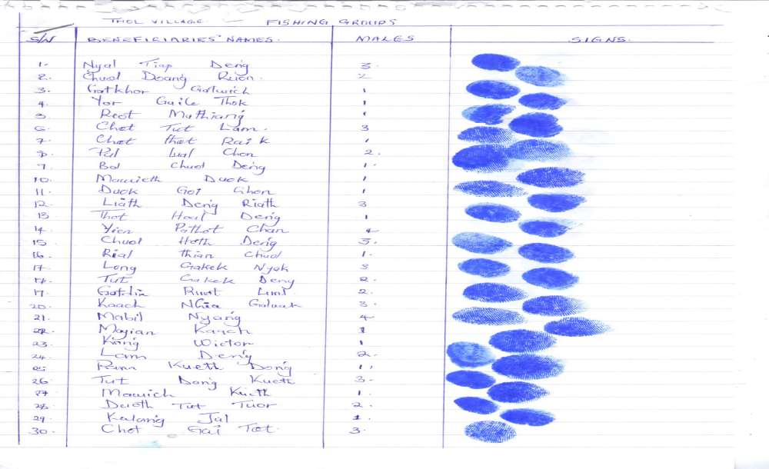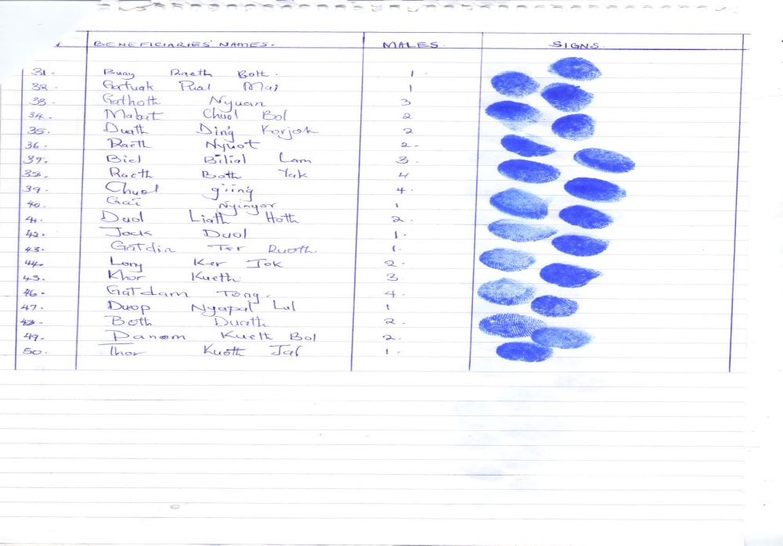

The report should not exceed 5 pages. This LoA interim report is intended for reporting only ONE LoA. Do not combine different LoAs under one LoA report.

